**G RAVINDERNATH YADAV**

B.Tech. – Metallurgical and Materials Engineering

Date of Birth: 09/07/2000

E-mail: ggrnathyadav2960@gmail.com

Contact: + 91-8978713329

[linkedin.com/in/g-ravindernath-yadav-424b3b195](https://www.linkedin.com/in/g-ravindernath-yadav-424b3b195/)

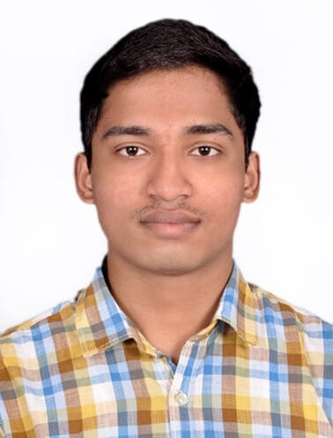

**Educational Qualification**

|  |  |  |  |
| --- | --- | --- | --- |
| **Year** | **Degree/Examination** | **Institution/Board** | **CGPA/Percentage** |
| 2020-Present | B.Tech. - MME | NIT, Trichy | 8.16 |
| 2019 | Class XII | Rashtriya Indian Military College, Dehradun, CBSE | 76% |
| 2017 | Class X | Rashtriya Indian Military College,  Dehradun, CBSE | 8.8 |

**Academic Achievements**

* Secured AIR 118 in UPSC National Defence Academy (NDA) 2019.
* Secured AIR 1 in Rashtriya Indian Military College, Dehradun (RIMC) entrance examination 2014.

**Internship Experience**

* **Data analytics intern at D’Well Research**  Aug2022 – Current

Working with a team of 15 analysts on quantifying the customer experience of products and services and analysing interesting patterns to draw insights useful for product development and decisions. Responsible for designing and maintaining data systems and databases and mining data from primary and secondary sources. Which are later processed with analytical tools to gather insights.

* **Campus Leadership Intern at Rysecamp Technology Pvt ltd.** Feb 2022 - Apr 2022 Rysecamp is a short duration education platform currently working on expanding its userbase and fine tune their offering. Worked with Rysecamp team to test and evaluate their application among college students. Introduced the app in NITT and grew the community of users to 150+ students. This testing helped gather useful insights regarding the feasibility of such platforms and customizations which were then incorporated into their services.

**Projects**

* **Fraud Transaction detection on banking transactions**  July 2022 Created a Tree based ML model to identify the fraud transaction in the data. Read research papers to solve the class imbalance in data. Used T-links followed by random under sampling to handle the class imbalance and thereby improving the accuracy of the model
* **Fake News Classifier and movie recommendation model** June 2022 Classified fake news by pre-processing the data by using NLP packages such as nltk and spacy.  Followed by classification using Navies Bayes model achieving an accuracy score of 75%. Pre-processed the raw data from the IMDB dataset into clean tokens after lemmatization. Recommended the movie like the user using the tf-idf and cosine similarity method.
* **Risk to Reward analysis using Sharpe Ratio** May 2022 Compared different investment opportunities among IT stocks listed on the National Stock Exchange and identified the best investment with lowest risk and highest reward, subsequently using the results to take positions. Employed the principles of Sharpe test and Data visualization.

**Technical Skills and Certifications**

* Programming Languages : Python, JavaScript, SQL,C++
* Analytics Software : Microsoft Excel, Microsoft BI, Tableau, Google data studio
* Certifications : Feature Engineering for NLP, Supervised, Unsupervised Learning in Python

**Positions of Responsibility**

* **Manager at Social Council NITT :** Feb 2022 – Current

Social Council overlooks the societal aspects in and around the college campus. Coordinated with a team of over 100+ students across multiple sub-teams for the smooth functioning of Council for **HumaNITTY**, a charity based weeklong donation drive for the needy which includes raising of funds, organising, scheduling of event, crowd management. Volunteered in association with the administration to help ease the onboarding of freshers in the campus.

* **Manager of the Prakruti Club NITT:** Feb 2022 – Current

Prakruti is the NIT Trichy’s Animal Welfare club which takes responsibility of strays inside the college campus. Part of the medical team consisting of 15 members which oversees the administration of pills and first aid to over 300+ strays. Additionally coordinated with the blue cross to provide advance medical care in partnership with the Govt veterinary hospitals and worked towards adoption of the pups and new born.

* **President of school aeromodelling club :** Jan 2014-2019

Coordinated among 20 cadets and Organised various air displays for over 400+ guests. Air displays include acrobatic flying, flower petal shower, banner display and night flying. Did special displays for the chief of army staff, the chief of Air staff and various other dignitaries and was part of the financial procurement of the planes and spares.

**Extracurricular Activities**

**Sport Activities:**

* Won the inter section Hockey championship twice (captained both the times)**,** lead my school team in district level hockey championship and was awarded with the best player and was awarded with a colour in hockey.
* Secured medals in inter district athletic championship: bronze in 4X100m and came 4th in 400m (broke my personal best) and medals in inter section athletics championship: gold in 100m,4X100 m relay, 400m and bronze in 4X400m relays.

**Adventure Activities:**

* Attended the adventure course in Mountaineering consisting of a 117 km trek to Sandakphu by Himalayan Mountaineering institute, Darjeeling.
* Rafting in grade 3 rapids of river ganga organized by army sports and adventure wing in Rishikesh.